lab_15.R

Sameeh

x = rnorm(15)  
x

## [1] -1.1264584 0.4585376 0.0509260 0.5082809 0.2767183 -1.1139096  
## [7] -1.6846917 0.1194973 0.6416810 -0.9894465 -2.5758814 -0.4897857  
## [13] -0.9549451 0.4271819 0.4220658

y = 2*x + rnorm(15)  
y

## [1] -1.15459019 0.41646483 0.41059581 2.85530427 0.10080244 -2.54872860  
## [7] -4.32409673 1.46773282 1.66173928 -3.80641100 -6.13992040 -1.68267662  
## [13] -2.22219507 0.05616117 2.41908126

model = lm(y~x)  
predict(model)

## 1 2 3 4 5 6 7   
## -2.6632223 1.3417101 0.3117661 1.4674002 0.8822930 -2.6315144 -4.0737538   
## 8 9 10 11 12 13 14   
## 0.4850306 1.8044726 -2.3170236 -6.3255919 -1.0544921 -2.2298464 1.2624812   
## 15   
## 1.2495539

sum(abs(predict(model)-y))/15

## [1] 0.7231605

data(airquality)  
names(airquality)

## [1] "Ozone" "Solar.R" "Wind" "Temp" "Month" "Day"

plot(Ozone~Solar.R,data=airquality)  
  
model1 = lm(Ozone~Solar.R,data=airquality)  
  
abline(model1,col="red")

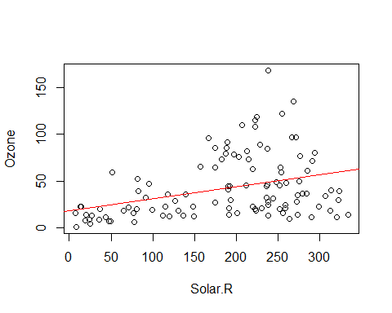

summary(model1)

##   
## Call:  
## lm(formula = Ozone ~ Solar.R, data = airquality)  
##   
## Residuals:  
## Min 1Q Median 3Q Max   
## -48.292 -21.361 -8.864 16.373 119.136   
##   
## Coefficients:  
## Estimate Std. Error t value Pr(>|t|)   
## (Intercept) 18.59873 6.74790 2.756 0.006856 **   
## Solar.R 0.12717 0.03278 3.880 0.000179 ***  
## ---  
## Signif. codes: 0 '***' 0.001 '**' 0.01 '*' 0.05 '.' 0.1 ' ' 1  
##   
## Residual standard error: 31.33 on 109 degrees of freedom  
## (42 observations deleted due to missingness)  
## Multiple R-squared: 0.1213, Adjusted R-squared: 0.1133   
## F-statistic: 15.05 on 1 and 109 DF, p-value: 0.0001793